Intervention Plan

Name of Student: G****y S.

Age: 8

Date of Birth:

Grade: 3rd

Interventionist: Nicole Langlois

1. **Recommendations**

**General**

The first meeting with G****y occurred at Searcy McRae Elementary. The session lasted an hour and a half. The room was decorated in all things superhero as the teacher’s theme is Super Students. G****y and the instructor sat at a cluster of desks not far from the entrance doorway as to be far enough away from the other pair that it wouldn’t obstruct G****y’s learning. The instructor and G****y played a Getting to Know You board game, both of them sharing their answers for each question. The instructor wrote down G****y’s answers to the questions in order to appeal to her learning taste for the rest of their sessions. The instructor then administered the Flynt-Cooter Interest Survey by orally asking G****y the questions provided on the paper. G****y was more verbal during this part than the Getting to Know You game because she and the instructor had bonded through the time they had spent together. The instructor then read aloud *When I Grow Up* by Al Yankovic and provided G****y with a journal. The instructor asked G****y to write a couple sentences about what she wanted to be when she grows up and why. After allowing time for G****y to write as much as she wanted, the instructor administered the Garfield Writing Interest Survey. G****y indicated that she likes to write when she has a choice about what to write about. Then the instructor provided a ball and the pair went outside to toss it back and forth. The pair came up with a category (animals, colors, ice cream flavors, food), and then tossed the ball back and forth, shouting out an item pertaining to that category each time they caught the ball. Then they went back inside and the instructor administered the DIBELS. After the DIBELS assessment, the pair worked their way through *Word Magic Magnetic Sentence Builder* by Magnix, placing word magnets in the correct spots to make a rhyming statement. The instructor ended the session by reading *Penguin’s Big Adventure* by Salina Yoon.

During the second session, the instructor started by reading aloud *Gorillas in Our Midst* by Richard Fairgray and they discussed the irony in the story. Then the instructor administered the DSA, starting with Within Word. The instructor then administered the Ekwall-Shanker. Then the pair played a FCRR intervention called Syllable Graph. After picking up picture cards, G****y was asked to clap out how many syllables were in the word, then placed the picture card on a graph of syllable counts. Next, the instructor provided guided readers of different levels surrounding the level G****y is goaled to be at. G****y was asked to look through the books and choose the one that she thought was a right fit for her. She chose *A House for Herman*, and she and the instructor partner read the whole book. When asked if this was a good book for her ability, G****y responded with a yes. Next, the instructor administered the Flynt-Cooter. Finally, the instructor read aloud *Wild About Books* by Judy Sierra and asked G****y to write in her journal about how she feels about reading.

During the third session, the instructor started by reading *Unlovable* by Dan Yaccarino, then talked about the parts of a story using the S.T.O.R.Y strategy. The instructor then administered the listening portion of the Flynt-Cooter to check comprehension from the story read last week. Next the instructor provided a Making Words Activity folder and the instructor and G****y made words with post-it note letter blends while keeping the same beginning blend, but changing the ending and hearing the sound of the blend in each word. Then, the instructor and G****y played a Cause and Effect Match game to show G****y’s comprehension of an effect from an action. Then the instructor read *Leonardo the Terrible Monster* by Mo Willems and G****y wrote in her journal about her best friend. Then the instructor administered the DRA. Finally, the pair played “Phoneme Split and Say Intervention” provided by FCRR. In this game, a picture card was shown with Elkonin boxes underneath the picture, and G****y was asked to sound out the phonemes in that word while pushing a poker chip into its spot on the boxes.

To start the fourth session, the instructor read *The Adventures of Beekle* by Dan Santat aloud and G****y wrote in her journal about an imaginary friend. Since the instructor was aware of her love to draw, G****y was also asked to draw a picture of her imaginary friend. The instructor then administered the Repeated Sentences and Retelling the Story portions of the OLAI assessment to check for quick comprehension. Next the instructor provided a Making Words Activity folder and the instructor and G****y made words with post-it note letters to show how just changing one letter sometimes can create a completely new word that rhymes with the original word. Then the instructor administered the Ekwall-Shanker Sight Word Assessment, and G****y read 219 of 221 sight words correct. Next the instructor and G****y partner read *I Don’t Like Koala* by Sean Ferrell. Finally, the pair went out to the playground and played a Sight Word Lava Game. While standing on the edge of a big circle painted on the blacktop, the instructor placed sight word cards down face-up. G****y was told that they were at the mouth of a volcano and the only way to get across is to read the sight word correctly. If she said the sight word incorrectly, she was told the correct answer, and then the card was flipped over and she had to find another way across the volcano. When she c=got all the way across, she was challenged to make it all the way back to the side she came from only using the cards that she hadn’t already read. She completed this with ease, and only missed “shall”.

|  |  |
| --- | --- |
| Strengths | Deficits |
| * Knowledge of good age-appropriate literature * Eager to learn * Engaged and a very good listener * Long Vowels * R-Controlled Vowels * Comprehends Main Problem * Character/Characterization * Applying background knowledge to passage * Syntactical Cues * Visual Cues * Auditory Comprehension * Verbal Retelling * Visual Cueing * Sight Word Fluency | * Other Common Long Vowel * Complex Consonants * Abstract Vowels * Inferential Comprehension * Evaluative Comprehension * Meaning Cues * Odd Word Placement on the Page * Complete Comprehension |

**Specific Interventions**

* 1. **Comprehension**
     1. Bounce Retelling - Using *Turtle Island*, have the student recall the different parts of the story. On the playground, use the sidewalk chalk to mark a path including the story elements: title, characters, narrator, setting, fact or fiction, problem, beginning of the story, middle of the story, main event, end of the story, resolution. The instructor will demonstrate with a different, well-known story. "The title is Little Red Riding Hood. The characters are Little Red, Granny, the Wolf, and the Lumberjack. Who would the narrator be? Little Red would be, right? What about in the story of the three little pigs? Who is the narrator? *student answers*" Then let the student bounce the ball on each space as they identify that piece of the story the pair read earlier. Help the student by explaining terms they are uncertain of, and if they have trouble recalling a part of the story, allow them to look back in the book.
     2. Words in Context Word Express (found in Appendix A): The instructor will place the question cards face down in a stack. The instructor will pick up one card, read it aloud, and ask the student to clarify which option on the card is correct. For example, “If a farmer has to prod the cow to move, does he sing to it or push it?” Student states the answer (i.e., push it). The instructor will check to see if the answer is correct by looking at the second underlined word or phrase. If correct, the instructor gives the card to the student who keeps the card. If incorrect, the instructor states the correct answer, shows the card to the student, and places it at the bottom of the stack.
     3. Words in Context Word Why (found in Appendix B): The instructor will place the question cards face down in a stack. The instructor will pick up one card, read it aloud, and ask the student to clarify which option on the card is correct. For example, “Would you be delighted if you lost your pet?” Student responds, and then fills in the learning page with a definition of the word. Example; “No; because Delighted means happy, and I would not be happy if I lost my dog”.
  2. **Long Vowels**
     1. Phoneme Matching Vowel Picture Sort (found in Appendix H): The instructor will place vowel header picture cards face up on flat surface. Then they will mix and place the vowel picture cards face down in a stack. The instructor will select a card from the stack, name the picture, and say the vowel sound (e.g., “fan, /a/”). Then the instructor will place the picture in the column with the matching vowel header. Then the student will pick up a card, the instructor will name it, and the student will say the vowel sound, placing it in the correct column. Finally , the student will pick up the card, name it, say the vowel sound, and place it into the column with the correct header.
     2. Canned Sort (found in Appendix N): The instructor will place word cards face down in a stack. Instructor will select a card, read the word, and say the sound of the vowel (e.g., “beet, /ē/”), and determine if it was a long or short /e/. Then they will place it in the basket with the corresponding /e/. Then the instructor will draw a card, have the student say it, and then sound it out to see which basket it should go in. Finally, the student will pick up a card, say it aloud, focus on the /e/, and place it in the corresponding basket.
     3. A Diagraph a Word (found in Appendix O): The instructor will place the cards face down in a stack, the magnetic letters, and the diagraph cards face up in a row. The instructor will pick up a card, name it, segment it into individual phonemes (e.g., “fish, /f//i//sh/”). Then the teacher will select the letter tiles that correspond to the phonemes and places them in the correct order (i.e., f-i-sh). Then she will says the sounds of each letter(s), blends them, and reads the word orally (i.e., “/f//i//sh/, fish”). Next the instructor will pick up the card, name it, and have the student help segment it. Then they will pick the letters that finish the word, and they will blend the sounds together. Finally, the student will draw a card, say it, segment it, and find the missing sounds.
     4. Short and Long (found in Appendix P): The instructor will place the cards face down in a stack. Then she will pick the top card, read the word, say the vowel sound (e.g., “past, /a/”), and place it in the column that matches (/a/). Then she will pick a card, have the student read it, and then emphasize the vowel sound and place it in the correct column. Finally, the student will pick the card, say the word, point out the vowel, and then place it in the correct column.
  3. **Phonemic Awareness**
     1. Syllable Graph (found in Appendix D): The instructor will pick up a card, say the word, then tap out how many syllables are present, and place the card on the graph above the correct number of syllables shown. The instructor will then say, “Now read pick up a card, we will read it together and tap out how many syllables are present. Then help me decide where I should put this card on the graph.” Finally, the instructor will say, “It is your turn to name the item, tap out the syllables, and place the card on the graph.” Continue taking turns until all of the cards are on the graph.
     2. Phoneme Split and Say Intervention (found in Appendix E): The instructor will introduce the game, placing the item cards and the place markers in front of the student. “This is a picture of a fish. When I break down the sounds in fish, I am going to push these little hexagons up into boxes when I start a new sound. Watch me. /f/ *pushes a hexagon into the first box* /i/ *pushes a hexagon into the second box* /sh/ *pushes a hexagon into the third box*. /f/ /i/ /sh/. Fish.” “Now we will do one together. What item is this? *student answers* Correct, dog. What are the sounds in “dog”?” Instructor helps students sound /d/ /o/ /g/. The student pushes the hexagon into each box while naming the sound. “Great job! Now I would like you to do the next one for me.”
     3. Phoneme Segmenting Counting Sort (found in Appendix I): The instructor will place the number headings on a flat surface and stack picture cards face down at the center. The instructor will select a picture card and say the name of the picture (book). The she will “Finger tap” the number of phonemes while saying the word (e.g., “book, /b/ /oo/ /k/”). She will state the number of phonemes (i.e., “three phonemes”) and place the picture card under the correct number (i.e., “3”). Then the student will pick up a card, say the name, and the instructor will help count the phonemes. Then the student will place the card under the column with the correct amount of phonemes. Finally, they student will pick a card, say the name, count the phonemes and place it in the correct column.
  4. **Fluency**
     1. Sight Words Lava Game (sight words found in Appendix G). The instructor and the student will start at one side of the blacktop and work their way across by reading the sight words on the lava spot. Before the student moves to that square, he or she has to read it correctly. If he or she misses the word, the word card will be removed and the student will have to find a different way path across. If a player steps off of the word card without the golden giraffe, they have fallen into the lava and have to start over from the beginning. The golden giraffe is held by the instructor and is used to allow the instructor to leave his or her word card to remove a word card. The object of this game is to be there first to get to the other side without falling in the lava.
     2. Guided Readers: Let the student choose between different leveled guided readers. Some options are *A House for Herman* and *Baby Elephant's New Bike*. Let her choose which one she thinks is a good fit for her. Using the book she picked and starting on the first page, take turns reading each page to each other. This is called Partner Reading. As you are reading, observe the words she struggles on, and her emphasis on her words. If the text she picked is too hard for her, explain that some of the books you gave her to choose from were supposed to be too hard, and go down a level or two, depending on the severity of the struggle.
     3. Repeated Reading: The Haunted House (found in Appendix C). The instructor will have G****y read the passage while she records it on her phone. Then, the instructor and G****y will take turns reading the passage out loud with expression and fluently. After a couple times, when the instructor feels that she is reading more fluently, the instructor will have G****y read it one last time and record her again. Then, they will listen to the replaying of both readings to show G****y her progress.
  5. **Automaticity**
     1. Making Words Activity (found in Appendix F): The instructor will provide a manila folder with the beginning consonants page on the left, and the ending blends page on the right. Using post-it notes, cover each square with a sticky with that same letter or blend written on it. The instructor will ask say, “I am going to make a word using these letters and blends, watch me.” Then the instructor will say “Help me make a word. I will put this beginning consonant on, will you add the ending blend?” Then the instructor will say, “I want you to make a couple more words for me.”
     2. Fluent Phrasing (found in Appendix K): Instructor will place the sentence sailboats cards face down in a stack. The instructor will say, "I am going to take the top card and read line by line until I complete the whole sentence. While I am reading, follow along with me. When I finish, we will read the sentence together. For the second card, let's read it together. I will read one line and you read the line after. We will take turns until we have finished the sentence. Finally, I want you to stack the sentences by yourself. Rereading like this will help us become more fluent readers."
     3. Silly Sentence Mix-Up (found in Appendix M) - The instructor will place all of the 1 cards in a pile, the 2 cards in a pile, and the 3 cards in a pile. The instructor will say "I am going to pick one card from each pile, and see what kind of sentence it makes. We are going to write down our sentences in a journal. The first sentence is The student ate cookies in outer space. Is this a silly sentence? Yes! Put a smiley face next to it in your journal. Next, I'll pick a card and I want you to pick the other two. Hungry birds were ringing at the table. Does that make sense? No. Let's put the third card at the bottom of the deck and pick another one." At the end, the teacher will be able to evaluate the sentences the student has written.
  6. **Making Connections**
     1. Cause and Effect Match (found in the resources below): This game will be played outside on the black top. The cause and effect cards will be on opposite ends from each other. The student and instructor will be next to the cause cards that are formed in a stack. The effect cards will be a short distance away all laid face up. The instructor will draw a cause cards, hop down to the effect cards and find the match. Then the instructor will skip back to the cause cards. Now the student and the instructor will draw a cause card together and do the same things that the instructor did on the turn before. After that card, the student will do the rest of the cards independently.
     2. Words in Context Meaning Exchange (found in Appendix J): Place sentence cards (with underlined words) face down in a stack at the center. Place sentence cards with blanks and meaning cards face up. Working in pairs, student one selects the top sentence card from the stack and reads the sentence to student two and places it on the table. For example, “My mom was exhausted from working all day.” Student two looks for the sentence card that shows the same sentence with a blank for the underlined word. Then looks for the word or phrase that has the same meaning as the underlined word (i.e., very tired). Places the meaning card on the blank in the sentence. Places the sentences one above the other and reads both sentences. Reverse roles. Continue until all meaning cards are used.
     3. Story Element Sort (found in Appendix L) - The instructor will place the header cards face up in a row at the center, and the story element cards face down in a stack. The instructor will pick up the top card and read it aloud. The instructor will verbalize her thought process about the card she picked up (i.e., "A barn on a farm. Is that a character? A problem? I know! It is a setting. *picks up next card* 'love is powerful', would that be a problem? *student answers* Now, let's work through putting the rest of them in the correct columns."

1. **Conclusion**

G****y is 8 years old, and is in her first semester of 3rd grade at Searcy McRae Elementary. She is sweet, creative, respectful, and always hungering for more knowledge. She loves to read books like Junie B. Jones and The Magic Treehouse, play with her siblings, and draw. Her family reads with her, and she reads to them, and her parents help her with her homework. The assessments that G****y completed have shown that she reads orally very well, but also that she needs some guidance on understanding the text and reading for meaning. G****y is able to read almost every sight word she is given which shows great word attack, but has a difficulty turning those words into meaning when they are used in a story. When G****y becomes a more conscientious reader, she will be able to relay information from the text she is reading.

1. **Alternative Directions**

Futher Assessment

Use different interventions

Increased Partner Reading

Teacher Observation

Increased time for reading

Appendix A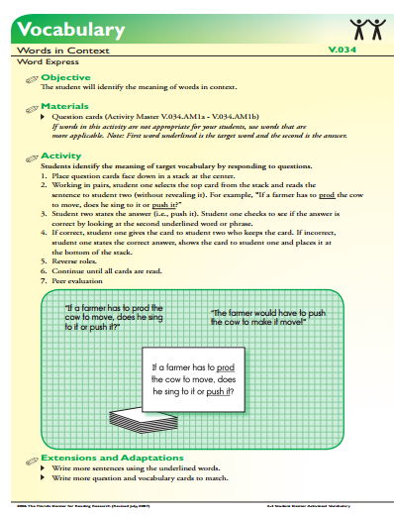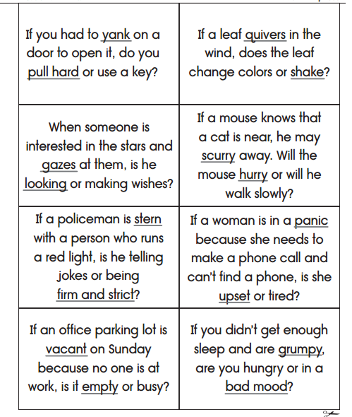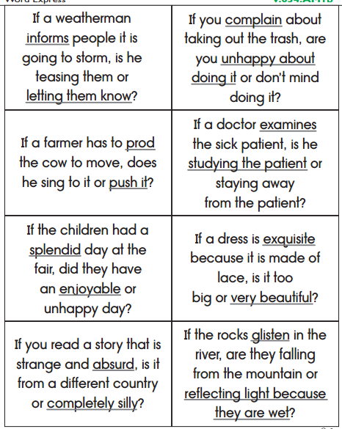

Appendix B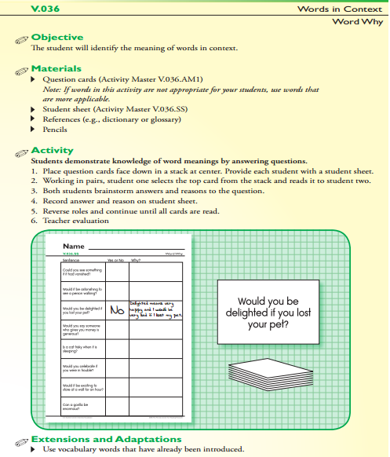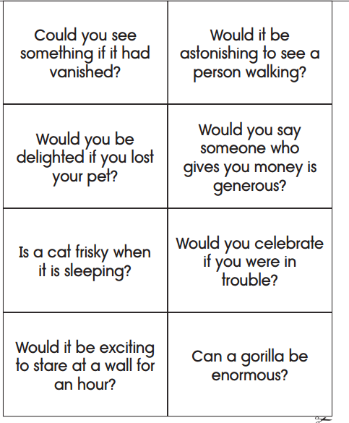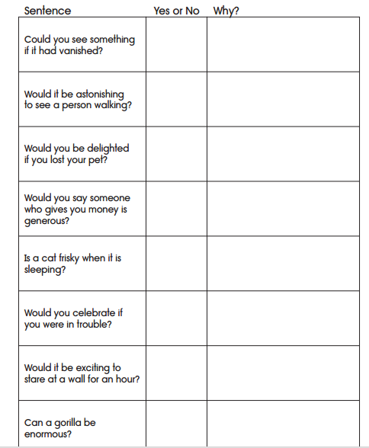

Appendix C

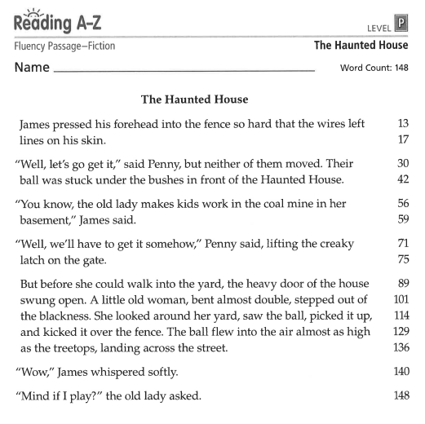

Appendix D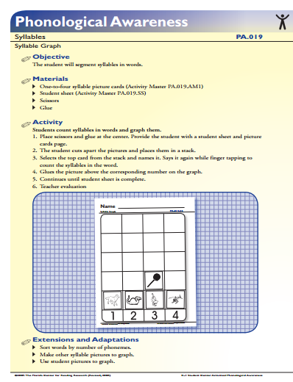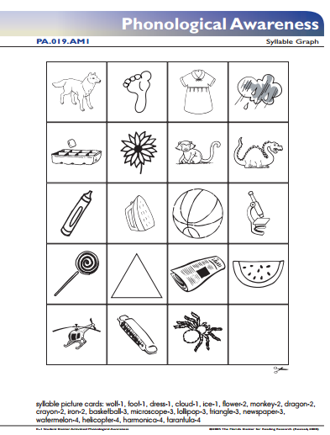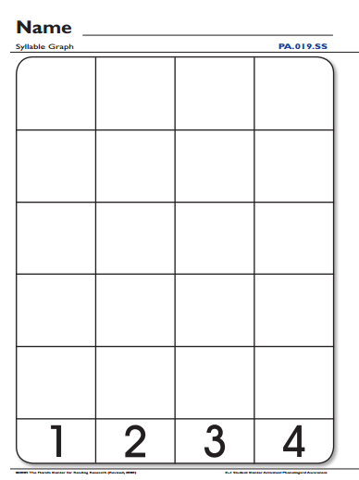

Appendix E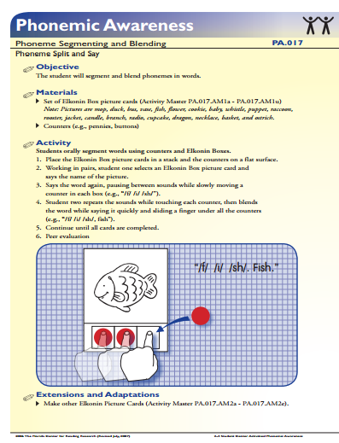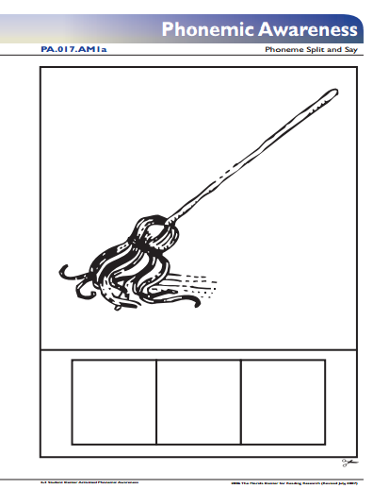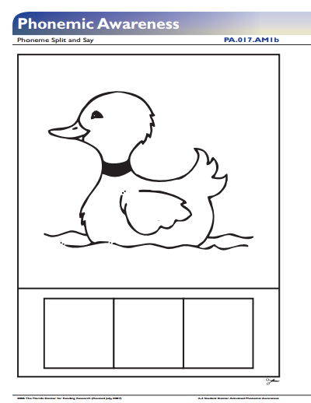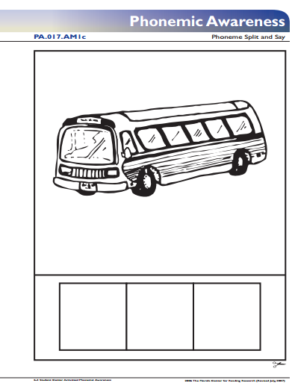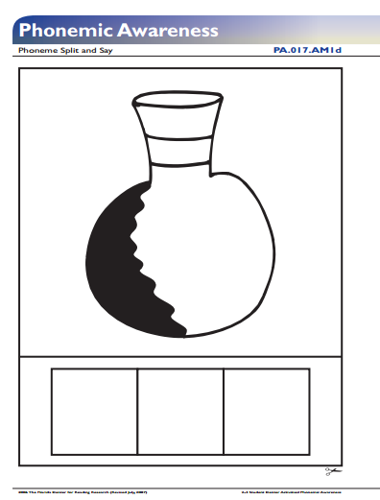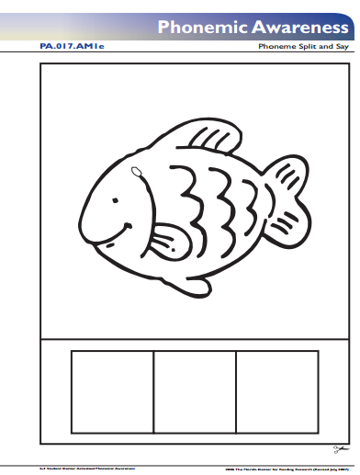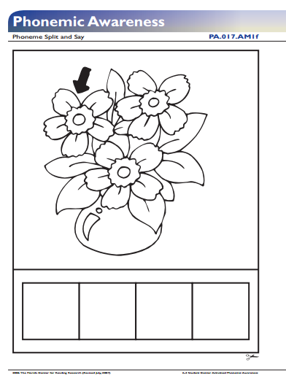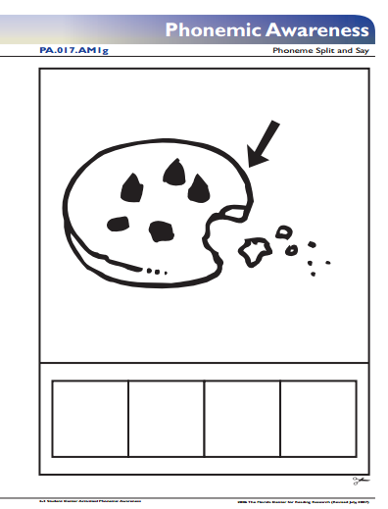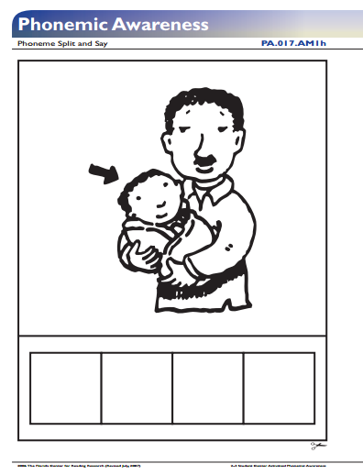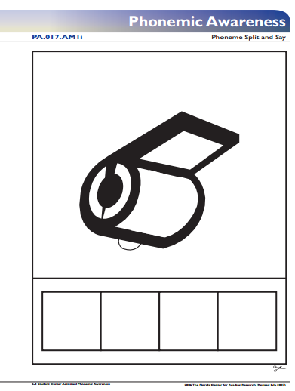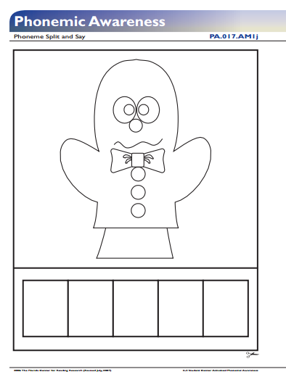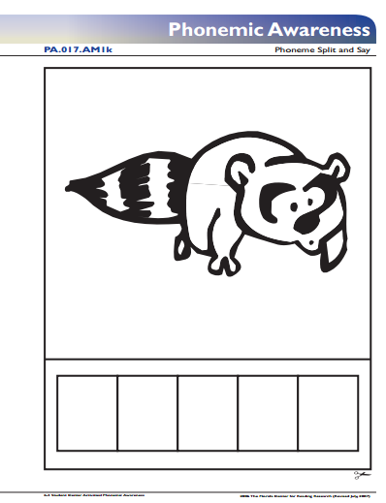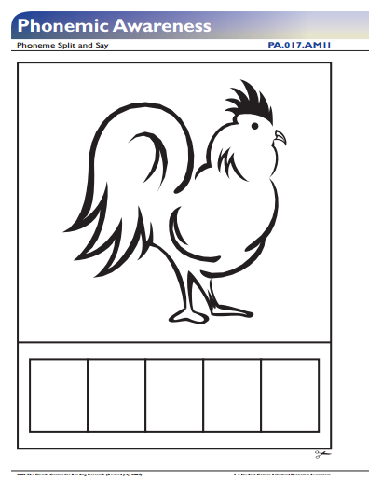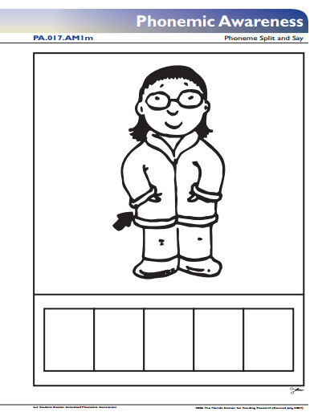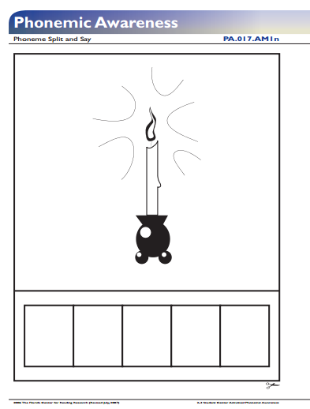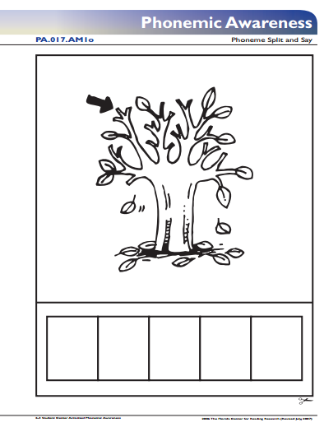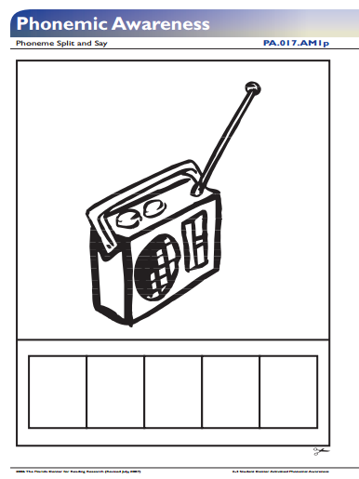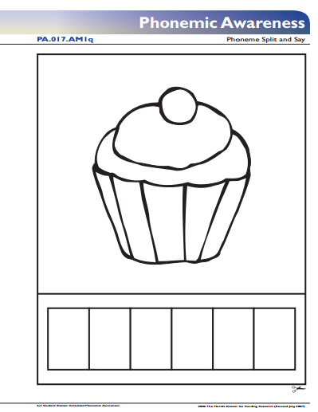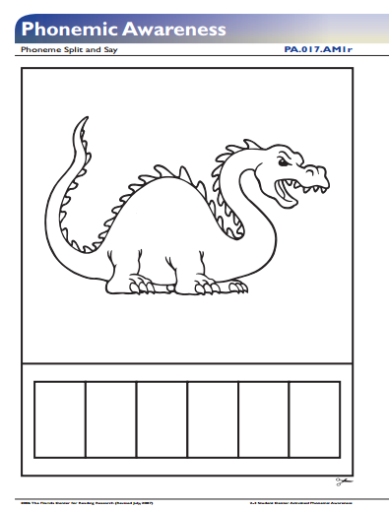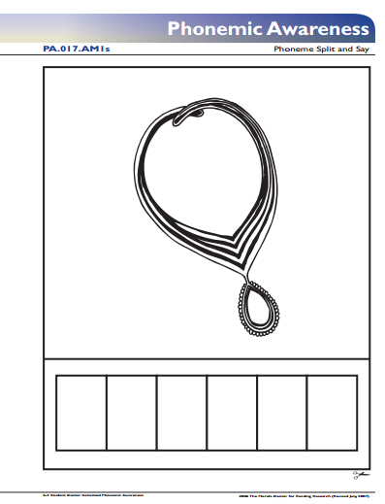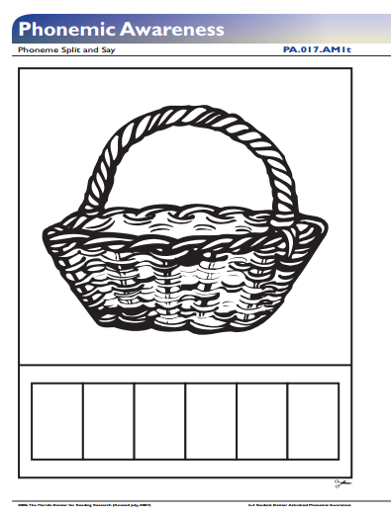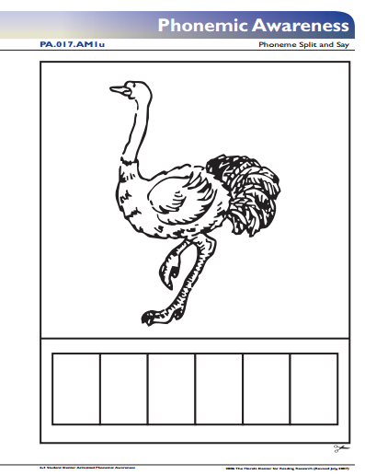

Appendix F

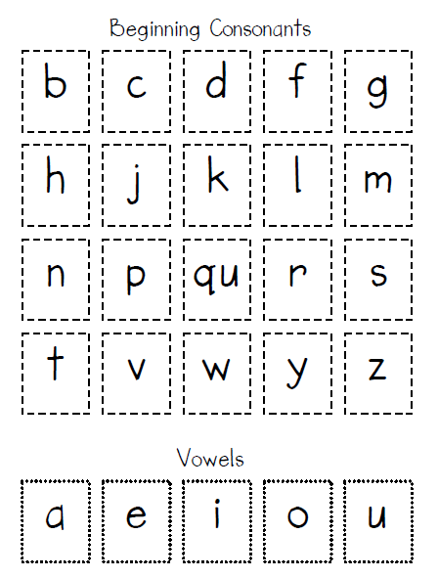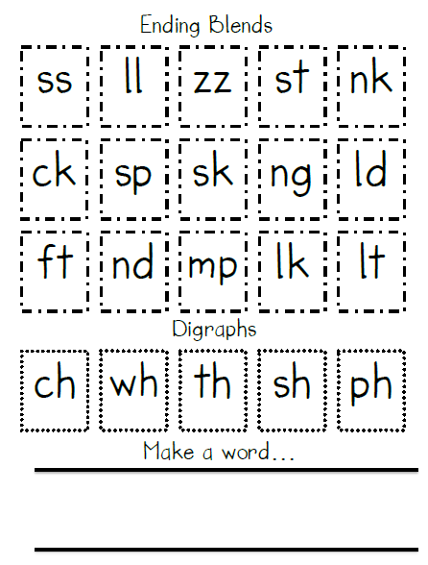

Appendix G

Sight Word Lava Game List:

Water

Coat

Thank

Live

Own

Window

Chair

School

Letter

Watch

Brother

House

Picture

Squirrel

Mother

Garden

Morning

Sister

Laugh

Shall

These

Together

Upon

Clean

Because

Found

Appendix H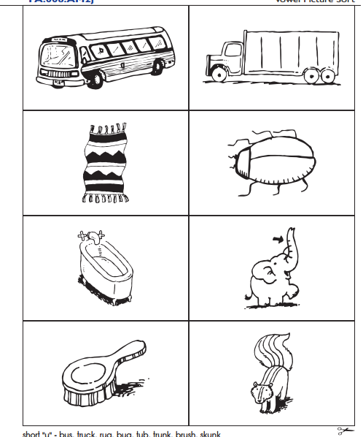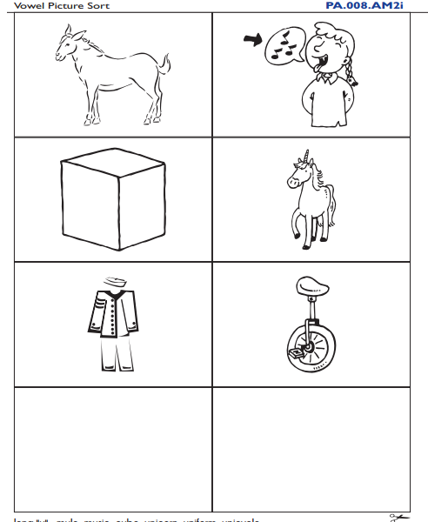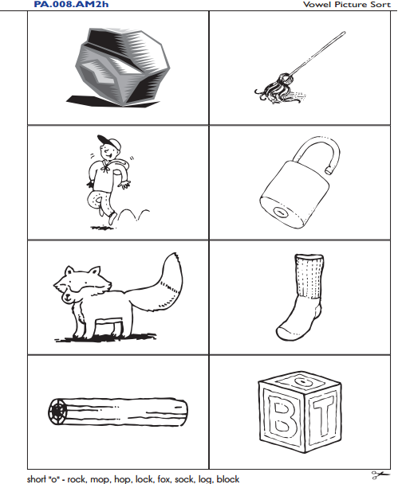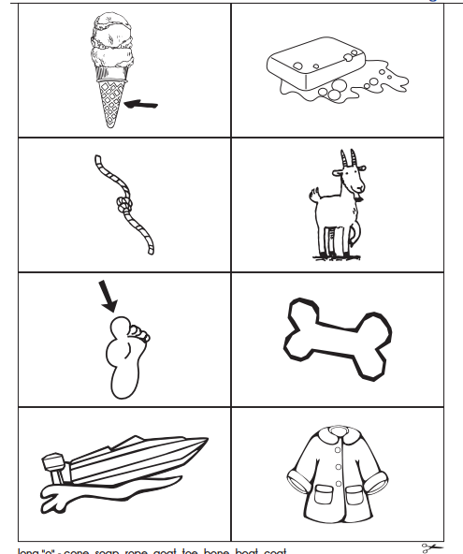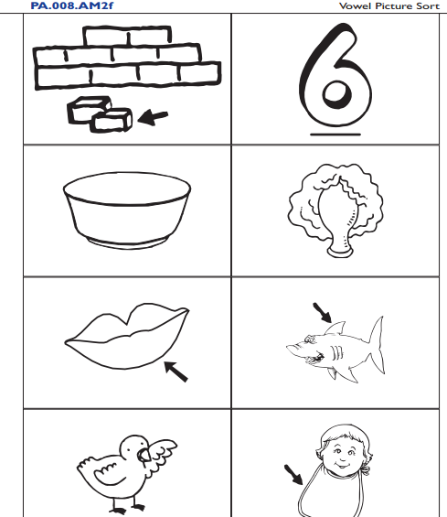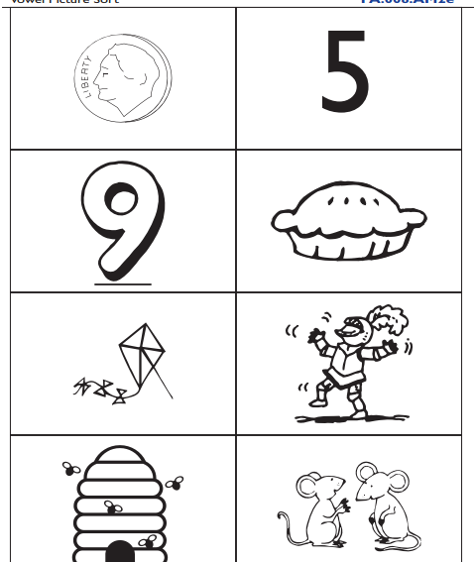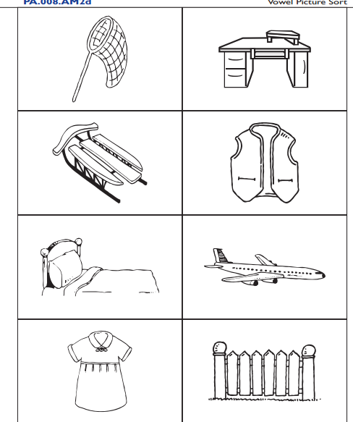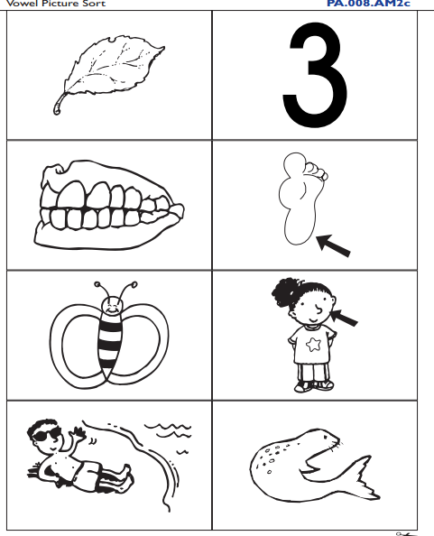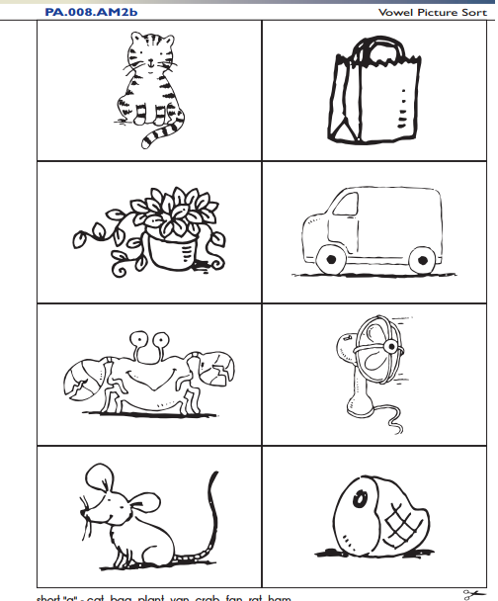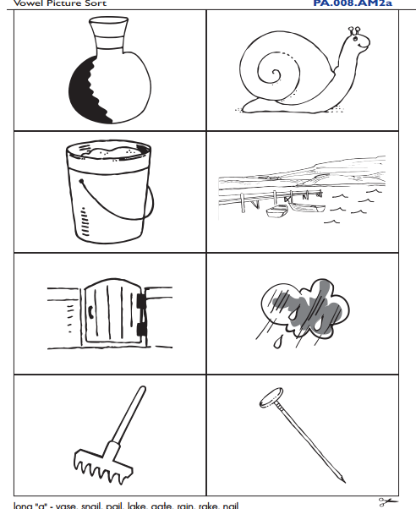

Appendix I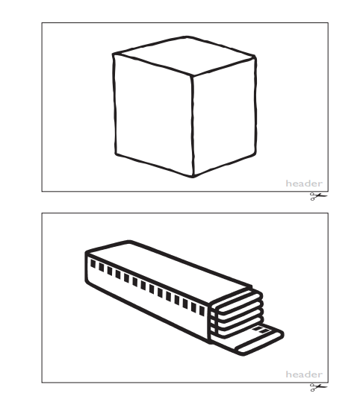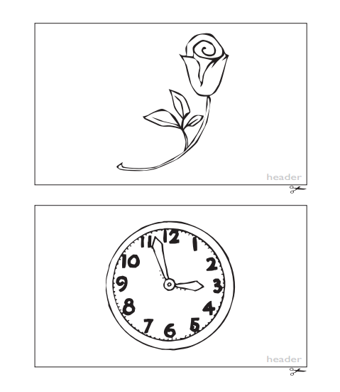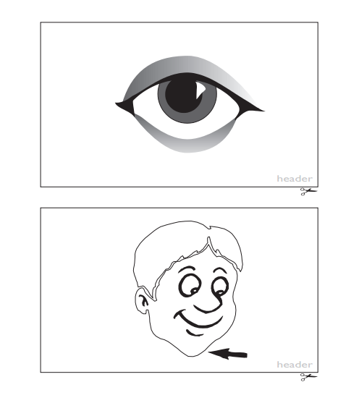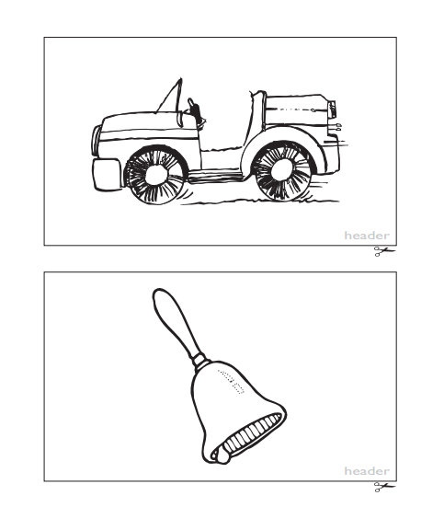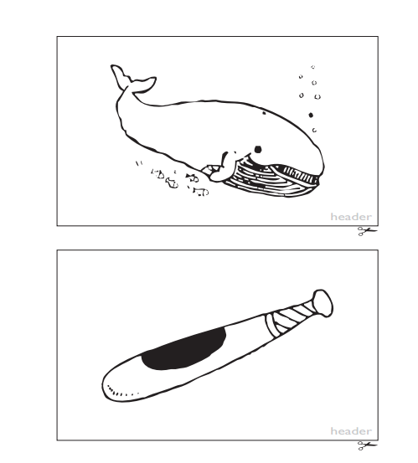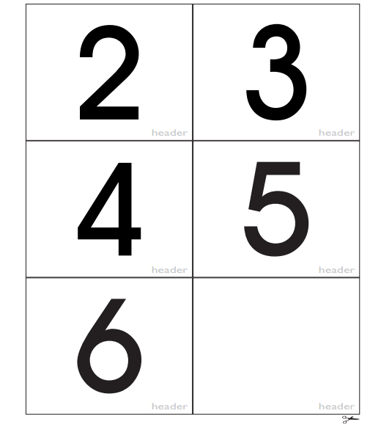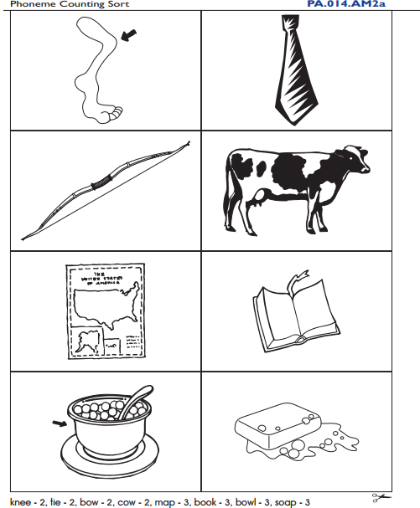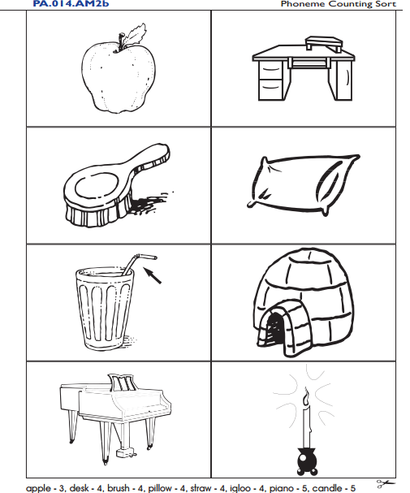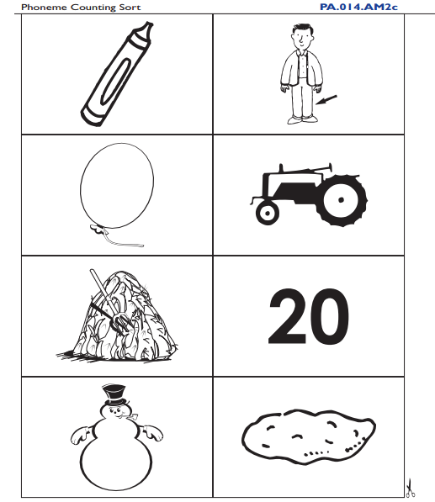

Appendix J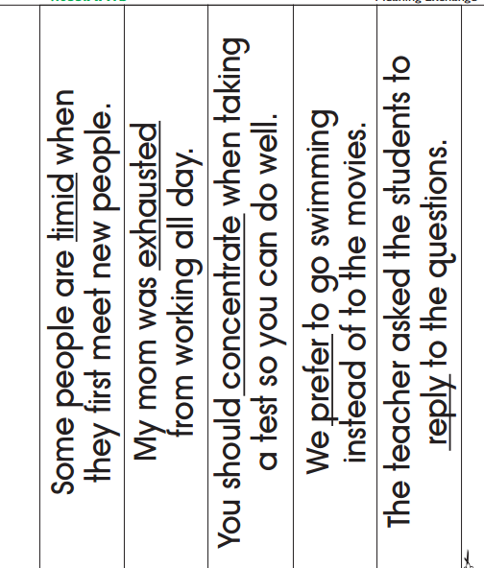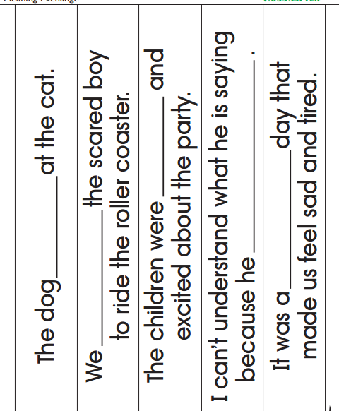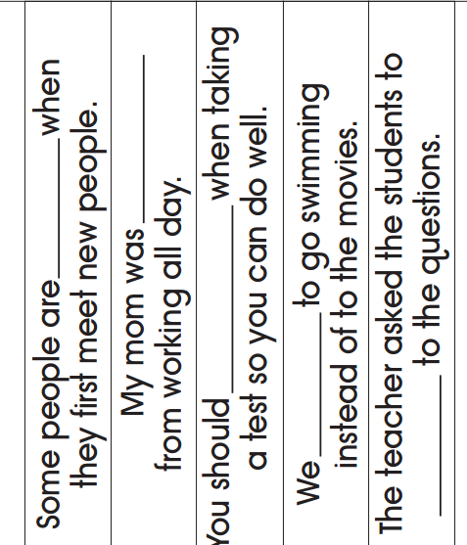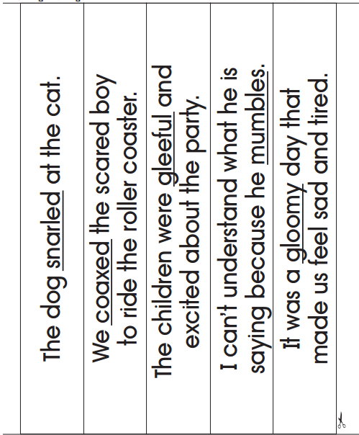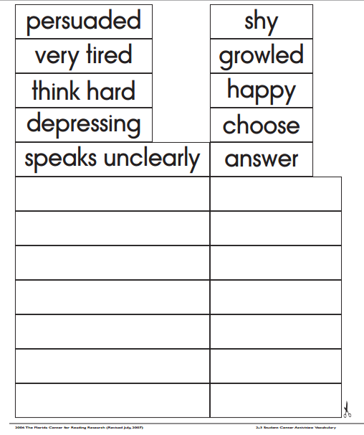

Appendix K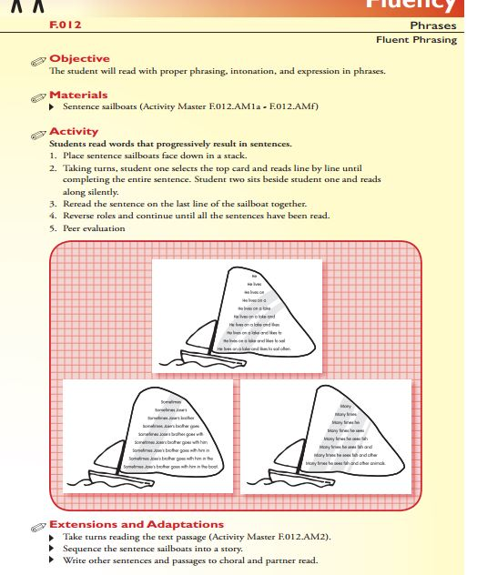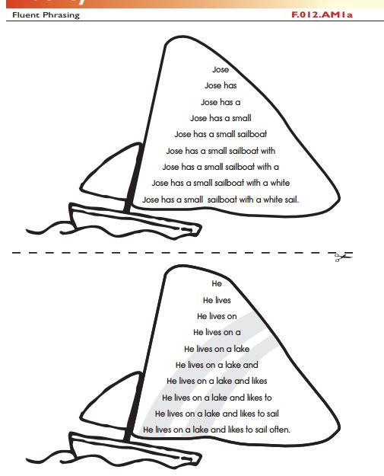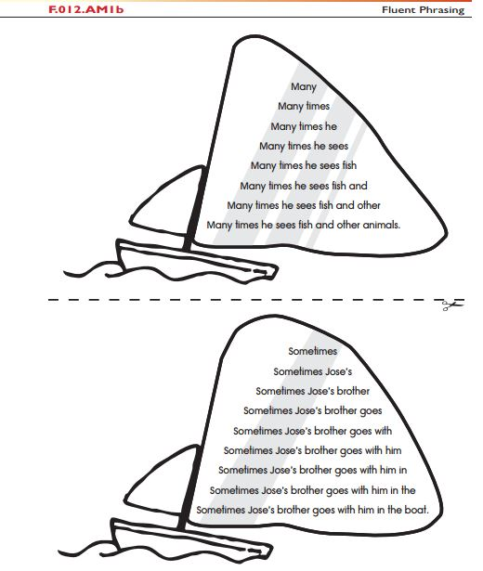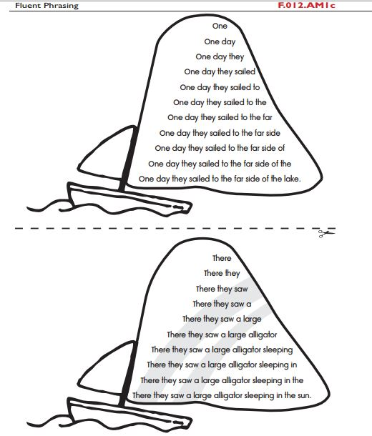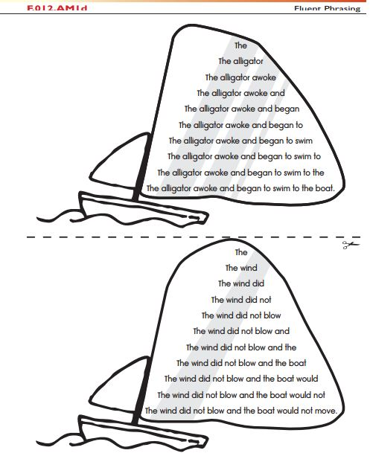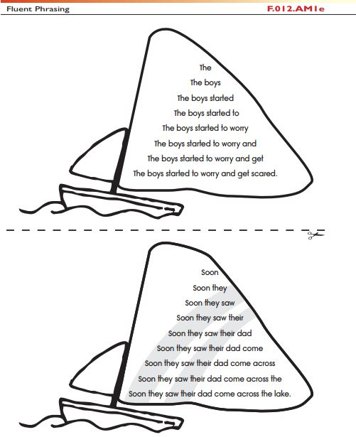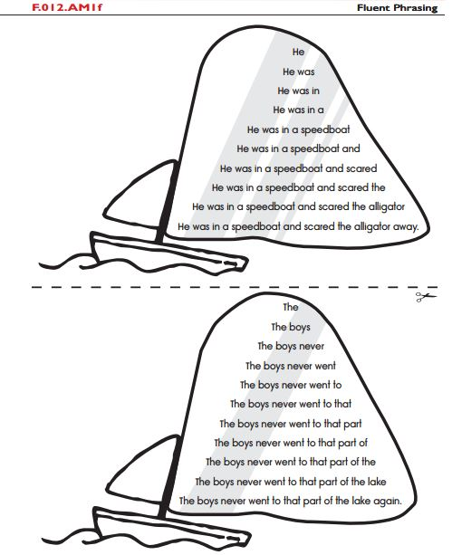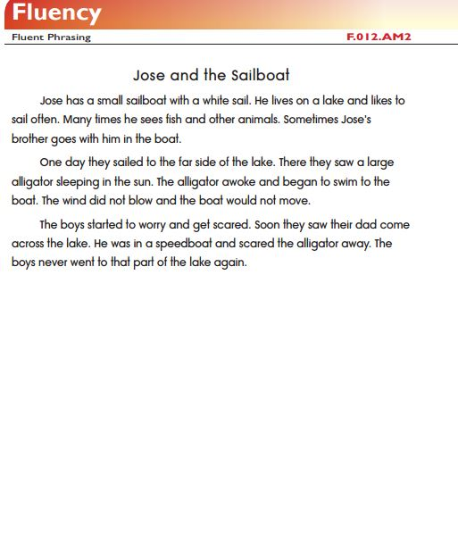

Appendix L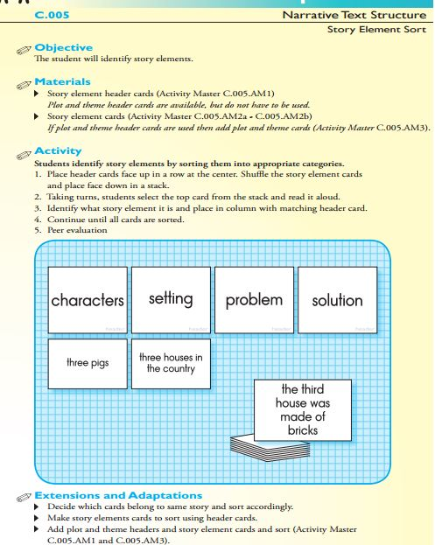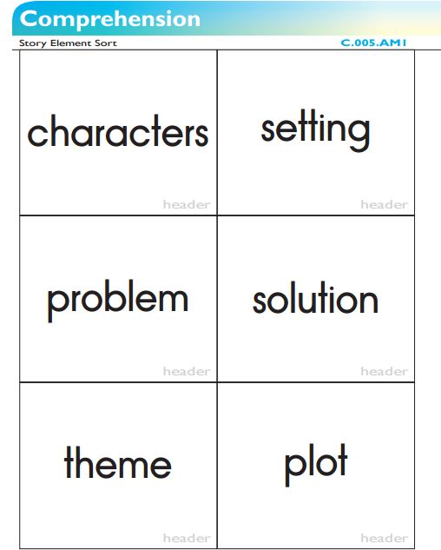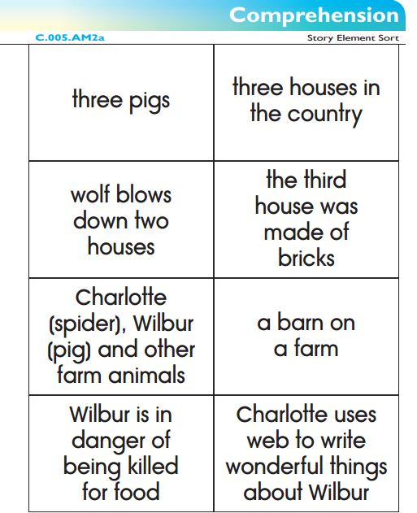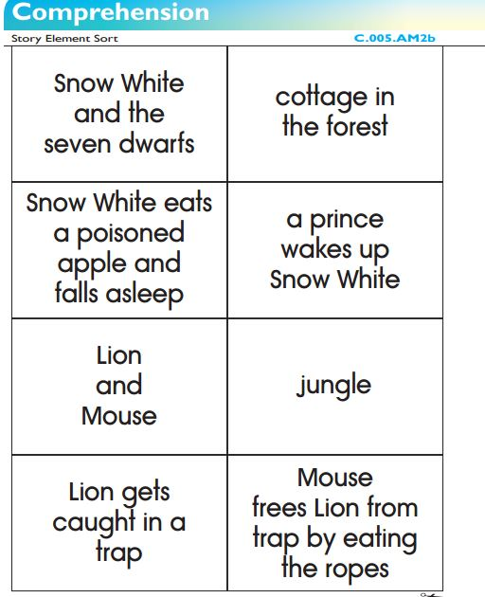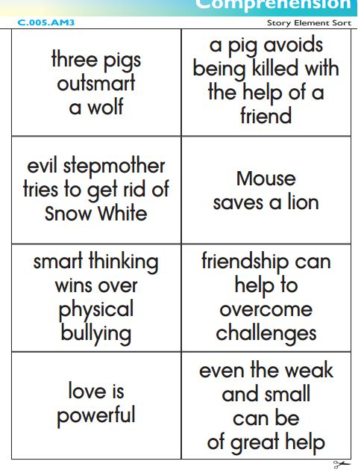

Appendix M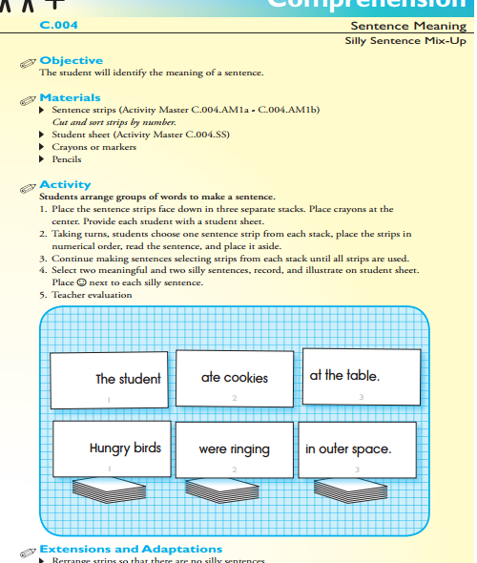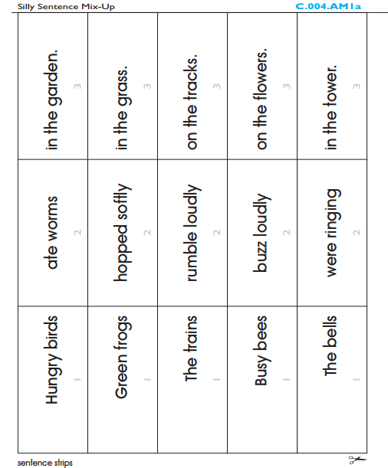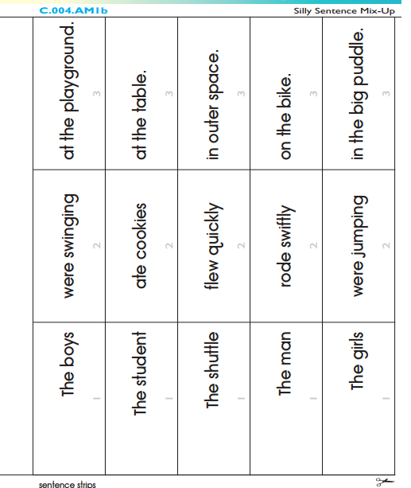

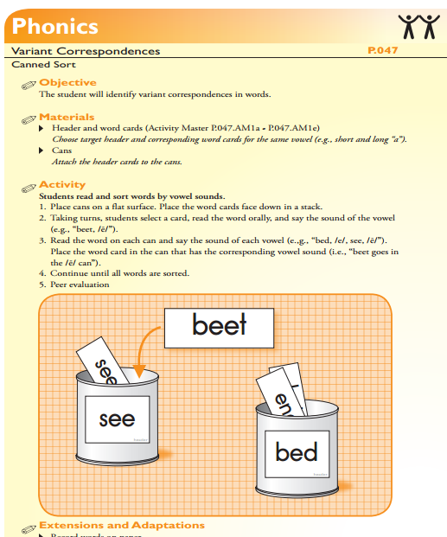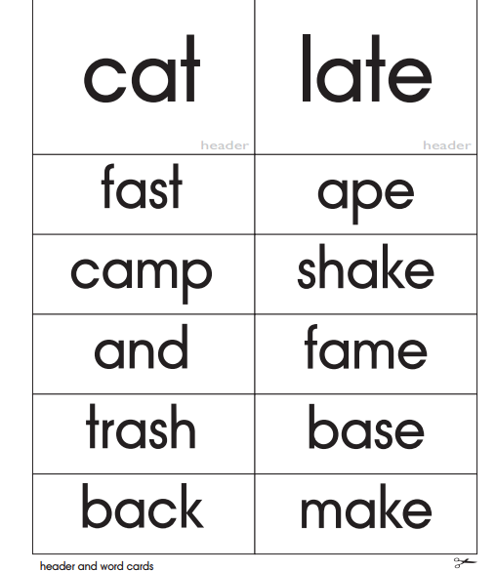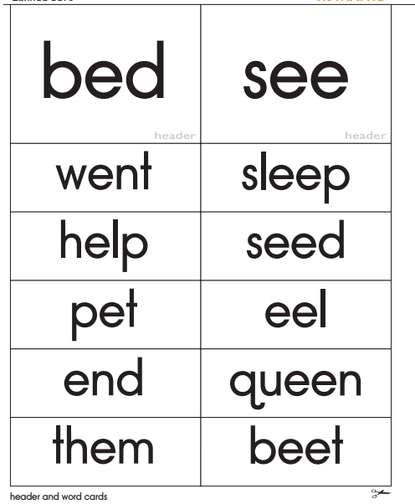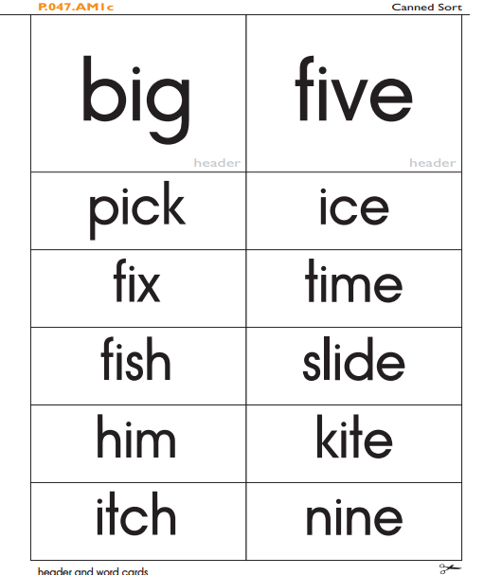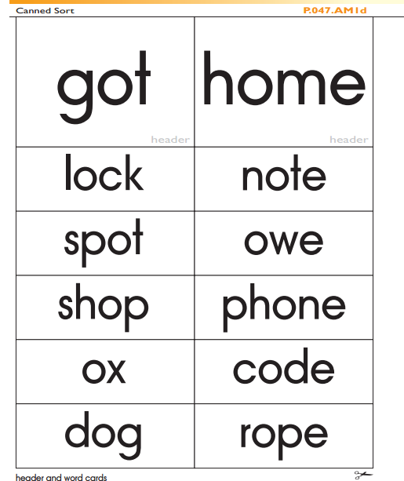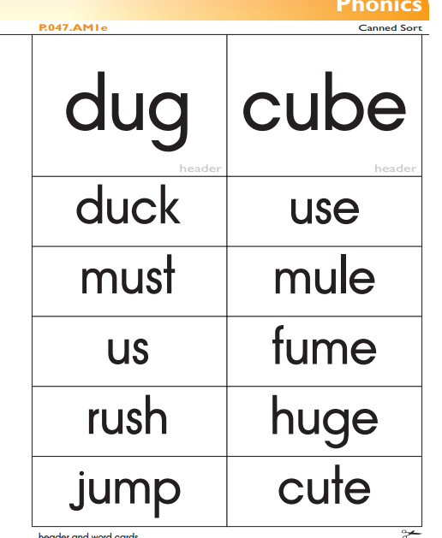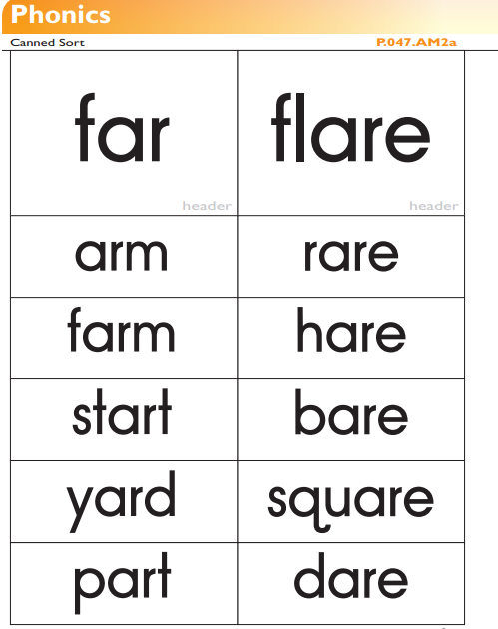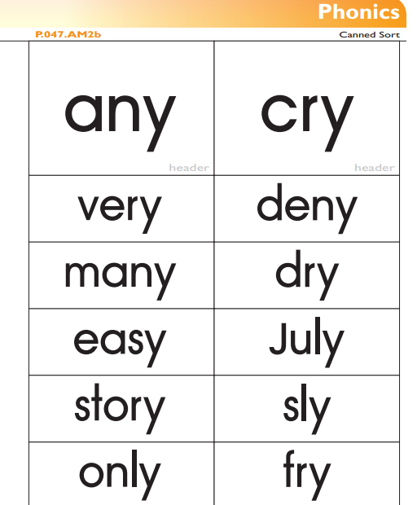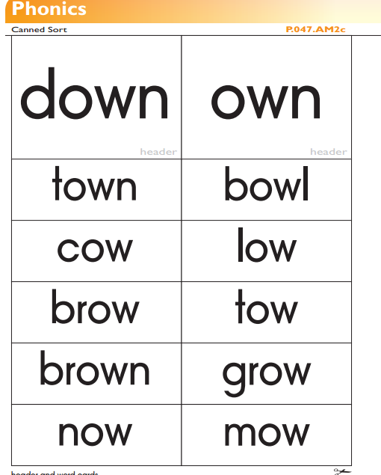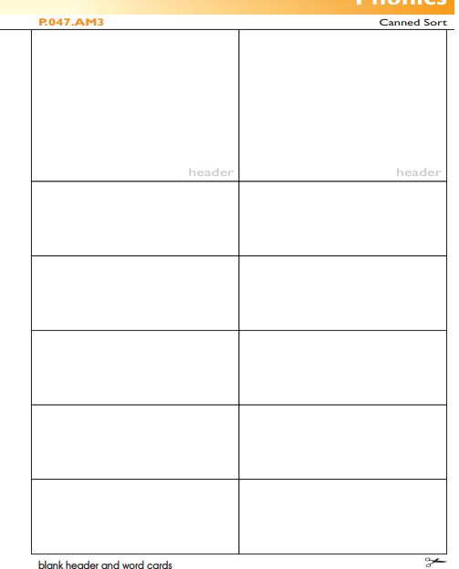

Appendix O

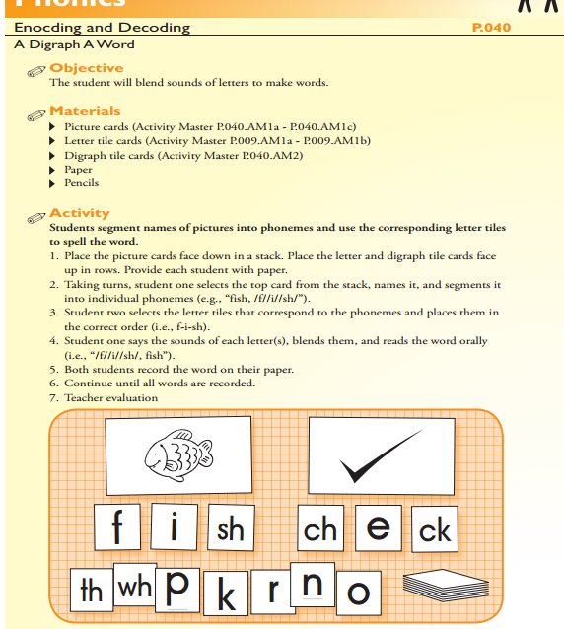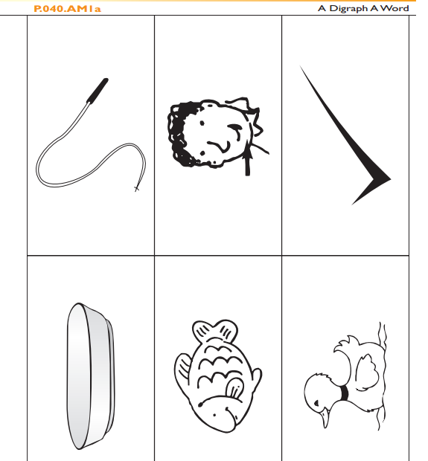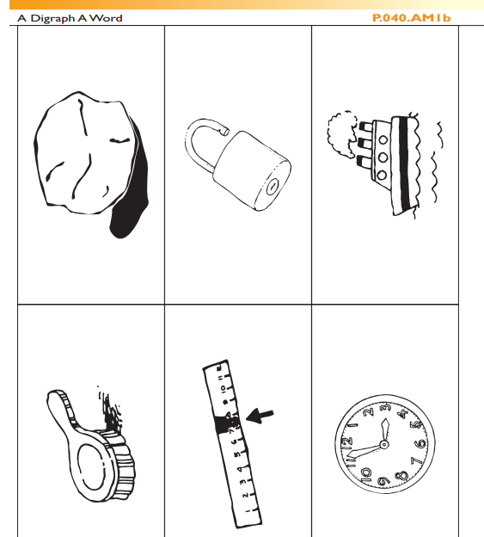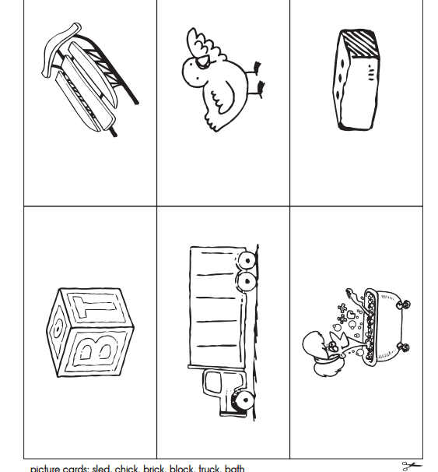

Appendix P